Skelton Court Singing for the Brain
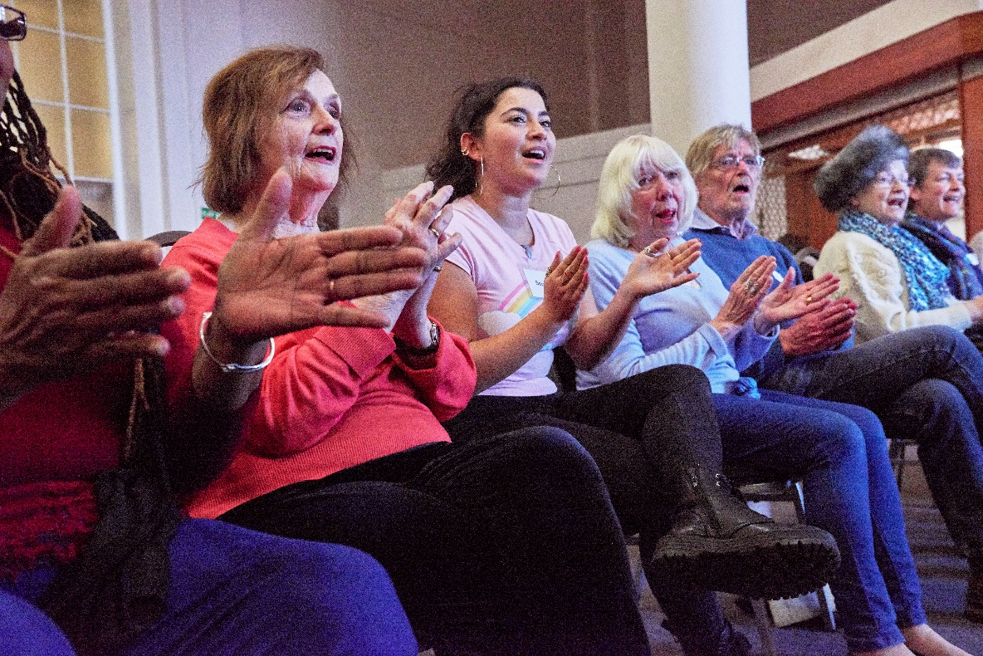

Every third Wednesday of the month
20 Sept, 18 Oct, 15th Nov and 20th Dec
2 til 4pm, no booking needed.
Call 07738741318 for more information
Skelton Court Care home, Station Lane, Skelton in Cleveland, TS12 2LR
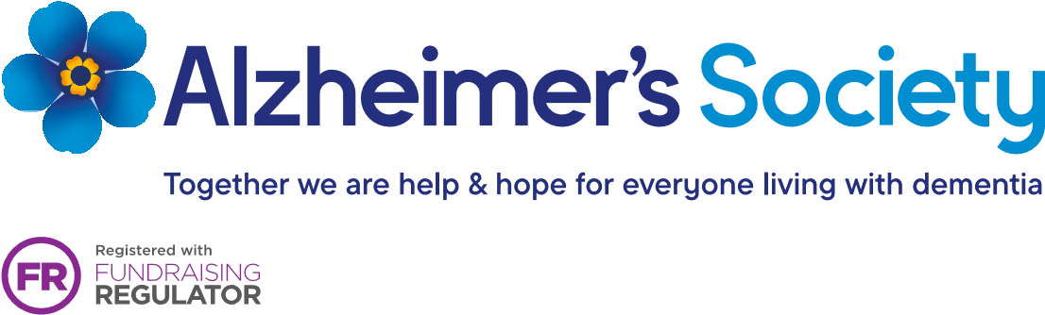
Registered charity no. 296645. Alzheimer's Society operates in England, Wales and Northern Ireland

